Rauma Art School kuvataidekoulu@rauma.fi
Lyseokatu 2, 26100 Rauma http://www.rauma.fi/kuvataidekoulu

GUARDIAN’S GUIDE 2022-2023
RAUMA ART SCHOOL

Welcome to school year 2022-2023

In this guide, you will find information about the school year and studies. For further information, please contact the teachers, the director of the Art School or visit our webpage www.rauma.fi/kuvataidekoulu.
After a couple of years, we will start a completely normal school year!
If there are changes to the pandemic situation, the teaching arrangements may change, if the authorities issue new recommendations or regulations.

The autumn term starts on Monday August 22nd 2022
Autumn holiday from October 24th to 28th 2022 (week 43)
No teaching on Independence Day, Tuesday December 6th 2022
The autumn term ends on Thursday December 16th 2022
The spring term starts on Monday January 9th 2023.
Winter holiday from February 20th to 24th 2023 (week 8)
No teaching on Maundy Thursday April 6th or on Easter Monday April 10th 2023.
School year ends on Thursday May 12th 2023 for Basic courses (Peruskurssit)
Thursday May 19th 2023 for Workshops (Työpajat)

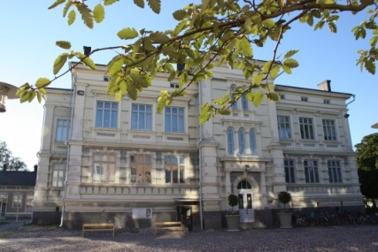
Monday 15.30-17.00 Basic course 1B
17.15-19.30 Basic course 5
17.15-19.30 Pottery workshop

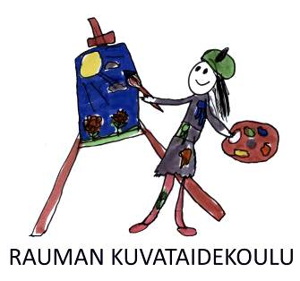
Tuesday 15.30-17.00 Basic course 3A
15.30-17.00 Basic course 4A
17.15-18.45 Basic course 1A
17.15-19.30 Drawing workshop

Wednesday 15.30-17.00 Basic course 3B
17.15-18.45 Basic course 3C
17.15-19.30 Installation art and printmaking workshop

Thursday 15.30-17.00 Basic course i 2A
15.30-17.00 Basic course i 2B
17.15-18.45 Basic course 4B
17.15-19.30 Painting workshop

The school has open doors in October from 3rd to 6th, when you can come and watch classes and ask questions about studying.

Old Rauma houses and markets - autumn exhibition in October at Optikkoliike Palmu's window, address Kuninkaankatu 10. Spring exhibition in the visual arts school's own building.

Follow Rauma Art School on Instagram: @raumankuvataidekoulu

t: Kirsi, Katariina, Emilia, Wihtori ja Vilma
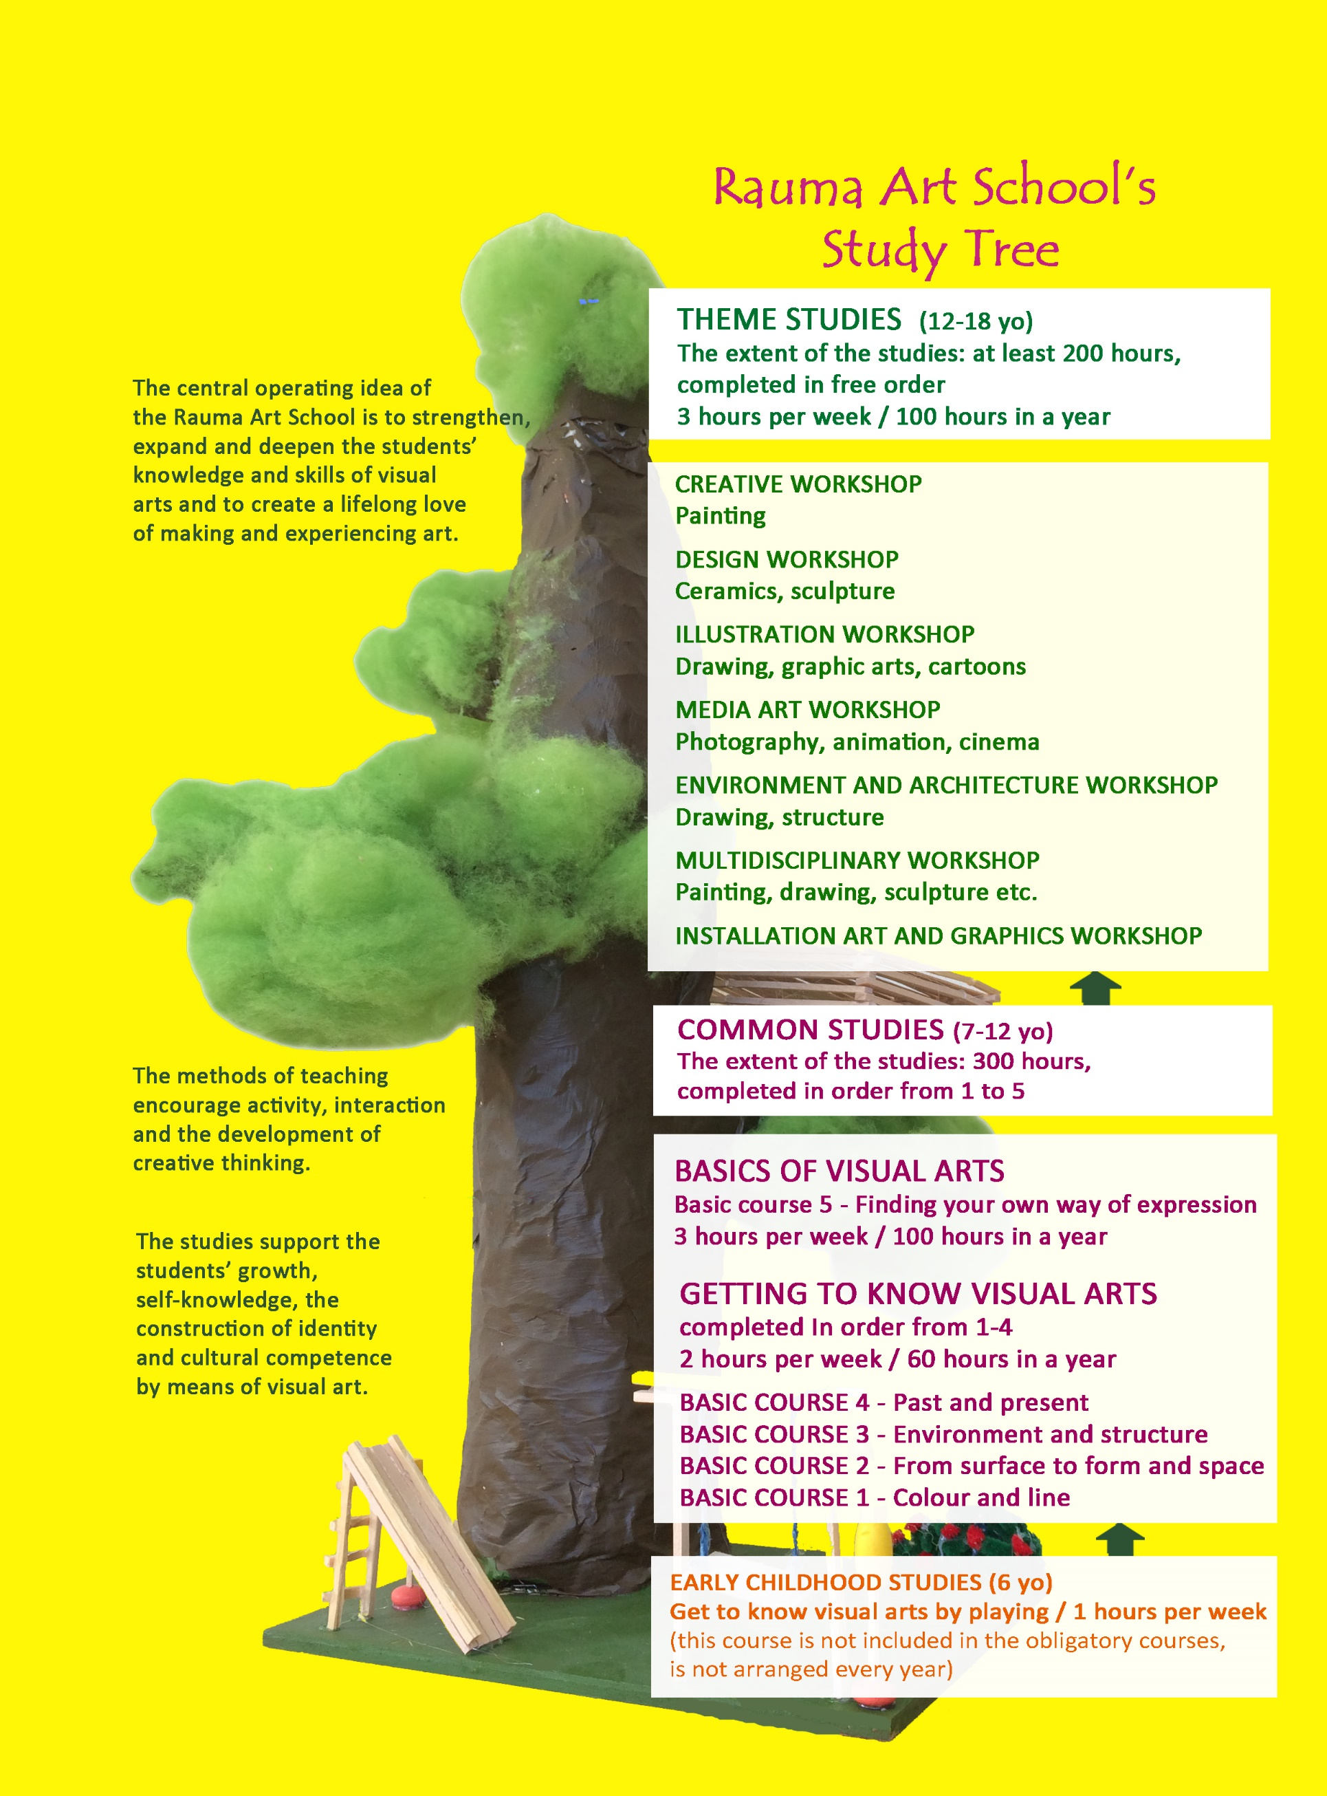

The structure of the Basic Education in the Arts

Rauma Art School offers teaching for children and youth aged six through 18.
The actual art studies begin with general studies of the basic courses. After completing them, the students move forward to workshop studies. The basic courses are usually completed in order and by age groups. The workshops can be chosen in your own preference and completed in any order. The selection of workshops varies yearly.
The courses of the basic studies are designed so that for completing each of them, the student is awarded 60 hours of studying in a year. For completing the workshop studies, the student is awarded 100 hours of studying in a year (1 hour of studying = 45 minutes). The teaching groups meet once a week in the afternoon or in the evening. When the student has completed 500 hours of studying, they will receive a diploma, which will be of great advantage when applying for further education in the arts.

We started implementing a new curriculum in the school year 2018-2019.
The current curriculum highlights the students’ involvement and influence, sustainable lifestyle and cultural diversity. For a more detailed description of the curriculum, please visit www.rauma.fi/kuvataidekoulu.
Kuusisto Kirsi, the director 044 793 3427
Teachers during the lessons 044 793 4512
Jokela Emilia
Mannio-Turunen Katariina
Roström Tommi-Wihtori
Wallenström Vilma
Adult Education Center Office 044 793 4515

You can best reach the teachers from Mon-Tues from noon to 2pm by their own phone
number. The teachers give their phone numbers to their own students at the first lesson.

The tuition fee is 240 €. The payment is invoiced in two instalments: 120 € in the autumn and 120 € in the spring. You are eligible for a discount of 20 € if a sibling of the Art School student also studies in Rauma Art School. You are also eligible for a discount of 20€ if the student of the Art School also studies in Taitava craft school or in Rauma Theatre School.

The application period for autumn ends August 18th 2022. Please contact the director of Rauma Art School Kirsi Kuusisto (tel. 0447933427 or email kuvataidekoulu@rauma.fi) for open vacancies during the school year and for further information about the studies.

Information on safety and studying

Listen to the teacher
It is important to carefully follow the teacher’s instructions for both safety and learning.
The comfort of working
Consider the other students and give everyone the opportunity to work in peace. Smartphones are kept in a backpack or "park" during lessons in order to focus on studying.
Health safety / Don't come sick
You may not come to art school if you are sick or have any symptons.
Hands are always washed when entering and leaving school. In case of a possible pandemic situation, the instructions given by the Institute of Health and Welfare (THL) will be followed.
Clean after yourself
At the end of the lesson, clean and tidy the area you have been using: return the materials and clean tools to their places and store your artwork in a place indicated by the teacher. After that, help to tidy the classroom. If a student purposely loses or damages the Art School’s tools or materials, they are obliged to compensate for the damage caused.
Be punctual
The teachers usually start the lessons by presenting the topic of the lesson and by giving technical instructions. Therefore, it is important to be on time. Please note that the teachers prepare for their lessons in class before the teaching starts. The teachers are responsible for their students only during the lessons, not before or after them.

Inform absences
The teaching is based on continuity. Often, the students work with one art piece for several lessons. Therefore, attending the lessons regularly is important for learning and progressing.

Dress appropriately
Please note that your clothing may get dirty from e.g. paints and inks. It may also be comfortable to wear separate shoes indoors. We advise you to wear some sort of shoes in class, because there may be e.g. clay or pieces of wood on the classroom floor. The Art School is not responsible for possible damage caused for the students’ clothing.

